**Skilaverkefni 1**

The Hungry Llama

The owners of the new restaurant, "*The Hungry Llama*," have hired you to create a landing page for their business. The landing page should be fully responsive for mobile devices and contain the following links:

* Home
* Menu
* About Us
* Contact

You have the freedom to set up the content on the landing page and decide whether the links will lead to separate pages or remain on the initial page. However, the restaurant owners would like the landing page to display or hint at some of the dishes that are being offered. The full menu should have its own sub-page.

Before beginning the coding process, it's important to have a loosely based wireframe of the project. This can be created using programs like Figma or online wireframing tools, or simply drawn with a pen and paper.

You are free to choose whatever color scheme you like

You will be judged on

| General look | 40% |
| --- | --- |
| Responsiveness | 25% |
| Code | 25% |
| Wire frames | 10% |

Content about the company and for the landing page and subpages.

The company slogan is “Where Good Food Meets Great Company - The Hungry Llama”

The company address is “1404 Food road”

The company phone number is “555-3212”

The company default email is “[frontdesk@hungryllama.com](mailto:frontdesk@hungryllama.com)”

The company preferred font is: Poppins, if you need a serif font that pairs well with poppins you can use [Playfair](https://fonts.google.com/specimen/Playfair+Display) font

Home

The landing page/Main site

Has to have

* Contain the company slogan
* A visually appealing hero section.
* Footer with the address, phone number and opening time

About us  
Welcome to The Hungry Llama, a family-owned restaurant that offers a unique and unforgettable dining experience. Our restaurant is inspired by the bold flavors and warm hospitality of South America, and we pride ourselves on serving fresh and locally sourced ingredients. At The Hungry Llama, we believe that food is not just a necessity, but an adventure, and we aim to take our customers on a culinary journey through our carefully crafted menu. Whether you're in the mood for a hearty meal or a light bite, our diverse menu has something for everyone. We also offer a wide selection of refreshing beverages and cocktails to complement your meal. Come join us at The Hungry Llama, where good food meets great company.

Contact

Form that includes

* Name
* Email
* Drop down selection ([<select>](https://www.w3schools.com/tags/tag_select.asp))
  + General request
  + Restaurants
  + Office
* Message ([texarea](https://www.w3schools.com/tags/tag_textarea.asp))

Menu (Idea, you can choose something else if you prefer)

Starters:

Chicken Caesar Salad with Romaine Lettuce, Grilled Chicken, Parmesan Cheese, and Caesar Dressing

Classic Cobb Salad with Grilled Chicken, Avocado, Bacon, Hard-Boiled Eggs, Tomatoes, and Blue Cheese Dressing

Asian Chicken Salad with Shredded Chicken, Mandarin Oranges, Crispy Wontons, and Sesame Ginger Dressing

Main Course:

Southwest Chicken Salad with Grilled Chicken, Corn, Black Beans, Avocado, Tomatoes, and Chipotle Ranch Dressing

Grilled Chicken Salad with Mixed Greens, Grilled Chicken, Cherry Tomatoes, Red Onion, and Balsamic Vinaigrette

Greek Chicken Salad with Grilled Chicken, Feta Cheese, Cucumbers, Kalamata Olives, and Lemon-Olive Oil Dressing

Buffalo Chicken Salad with Crispy Chicken Tenders, Mixed Greens, Carrots, Celery, Blue Cheese Crumbles, and Buffalo Ranch Dressing

Sandwiches:

Grilled Chicken Panini with Mozzarella Cheese, Roasted Red Peppers, and Pesto Mayo

Chicken Salad Sandwich with Shredded Chicken, Grapes, Almonds, and Lettuce on Whole Wheat Bread

Buffalo Chicken Wrap with Crispy Chicken Tenders, Mixed Greens, Blue Cheese Crumbles, and Buffalo Ranch Dressing in a Flour Tortilla

Sides:

Sweet Potato Fries

Garlic Parmesan Fries

Grilled Vegetables

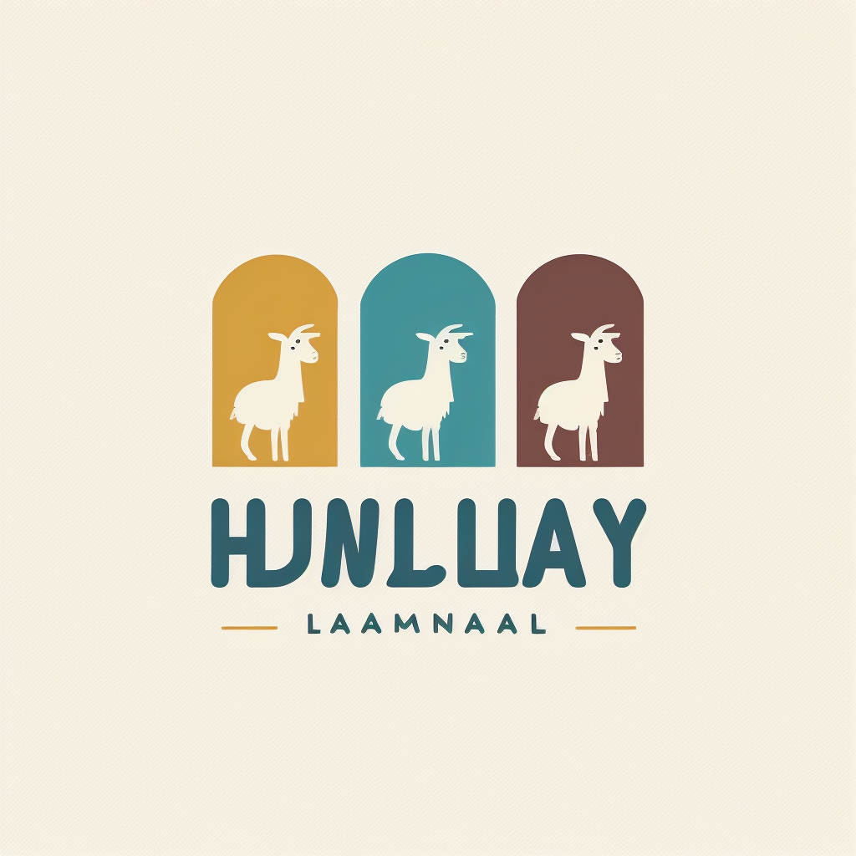

The owners have been experimenting with some logo design and you are free to use this logo or create your own. [Large](https://cdn.discordapp.com/attachments/1060564516179562556/1088427798684770365/FannarM_a_clean_simple_logo_for_the_restaurant_hungry_llama_usi_a9203242-b794-4f76-a696-f4e2ba3420f5.png)

